Australian Islamic College 2020
ATAR Chemistry Units 3 and 4
Task 11A (Weighting: 2%)

Polymers Test

Test Time: 35 minutes

Please do not turn this page until instructed to do so.

First Name | Surname
ANSWERS

Teacher

Mark / 34 | Percentage

Equipment allowed: Pens, pencils, erasers, whiteout, correction tape, rulers and non-programmable calculators permitted by the Schools Curriculum and Standards Authority.
Special conditions:

2 marks will be deducted for failing to write your full name on this test paper.

Teacher help: Your teacher can only help you during your test in one situation.
If you believe there is a mistake in a question show your teacher and your teacher will tell you if there is a mistake in the question and if appropriate, how to fix that mistake.

Spelling of Science words must be correct. Unless otherwise indicated, science words with more than one letter wrong (wrong letter and/or wrong place) will be marked wrong. The spelling of IUPAC names must be exactly correct.

Unless otherwise stated, equations must be written balanced and with correct state symbols or they will be marked wrong.

Questions must be answered in this booklet.

Total marks: 34

PART ONE: MULTIPLE CHOICE QUESTIONS (14 MARKS)
Circle the correct answers on the questions.
- Glucose molecules are joined in the human liver in a series of condensation reactions to form a condensation polymer called glycogen. Each time two molecules of glucose are joined a molecule of water is lost.
200 molecules of glucose, C₆H₁₂O₆, polymerise to form glycogen. What is the molar mass, in g mol⁻¹, of the resulting polymer?

  - 32450 g mol⁻¹
  - 32430 g mol⁻¹
  - 32460 g mol⁻¹
  - 36030 g mol⁻¹

- Ultra high molecular weight polyethylene (UHMWPE), which has a molecular weight in excess of 3,000,000 g mol⁻¹, is used to make bulletproof vests. In contrast, low density polyethylene (LDPE) is used to make thin plastic bags for bread and fruit. What explains why UHMWPE is so much stronger than LDPE?
  - UHMWPE has chlorine atoms that allow for dipole-dipole forces. These are not found in LDPE.
  - UHMWPE has nitrogen atoms that allow for hydrogen bonding. Hydrogen bonding is not found in LDPE.
  - UHMWPE has ester linkages. LDPE does not have these.
  - UHMWPE has much longer polymer chains than LDPE.

Questions 3 and 4 refer to the polymer shown below.
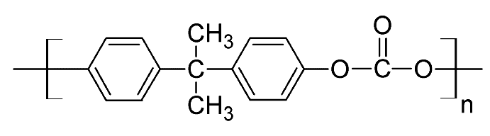
- What type of polymer is this?
  - Polyester
  - Polyvinyl
  - Polyamide
  - Addition

- Which intermolecular forces are present between molecules of this polymer?
  - Dispersion forces, dipole-dipole forces and hydrogen bonds.
  - Dispersion forces and dipole-dipole forces.
  - Dispersion forces and hydrogen bonds.
  - Dispersion forces, dipole-dipole forces, ion-dipole forces and hydrogen bonds.

- Shown below are two polymers.
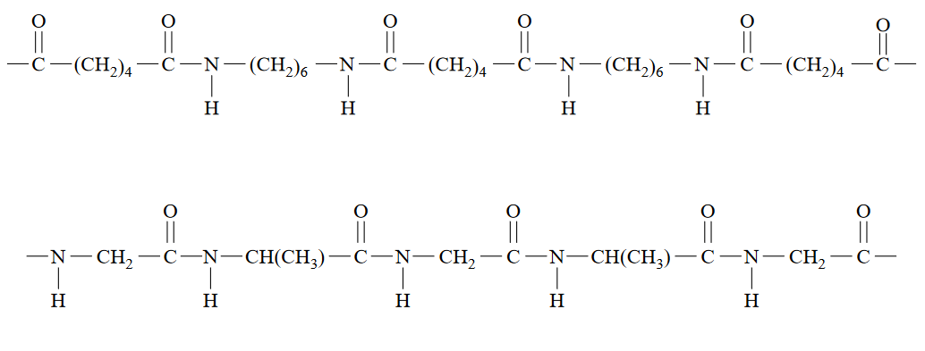
Which statement is true about these polymers?
  - Both polymers are polyesters.
  - Both polymers are addition polymers.
  - Both polymers are copolymers.
  - The strongest intermolecular forces in both polymers are dipole-dipole forces.

- Copolymers are obtained when two or more different monomers are allowed to polymerise together. Part of a copolymer chain is shown below.

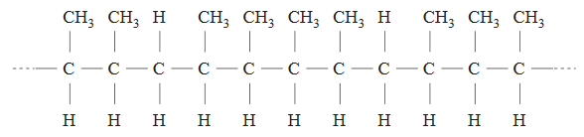

The two alkenes that could react together to form this polymer are
  - Propene and but-1-ene.
  - Propene and but-2-ene.
  - But-1-ene and but-2-ene.
  - Pent-2-ene and but-2-ene.

- Cuts and wounds are often stitched using a biodegradable polymer with the formula
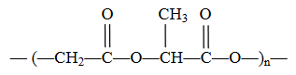

It is made from a condensation polymerisation reaction between lactic acid (HOCH(CH₃)COOH) and glycolic acid.

The formula of glycolic acid is
  - HOCH₂COOH
  - HOCH₂CH₂OH
  - HOOCCH₂COOH
  - HOOCCH₂CH₂OH

- The following structure represents the repeating unit of a polymer used in the manufacture of contact lenses.
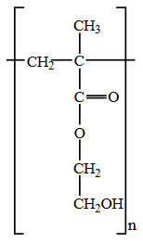

Which one of the following is a correct statement about the monomers that react to form this polymer?
  - Each monomer contains a double bond between carbon atoms which allows addition polymerisation to take place.
  - Two different monomers react to form the polymer, one with carboxyl groups and the other with hydroxy groups.
  - The total mass of the monomers is greater than the mass of the polymer formed because water is eliminated in the polymerisation reaction.
  - Each monomer contains both a carboxyl and a hydroxy group which allows condensation polymerisation to take place, forming a polyester.

- A short section of a polymer molecule is shown below.

-CH₂CF₂CF₂CH₂CF₂CH₂CH₂CF₂CH₂-

This polymer could have been formed from
  - CF₂CH₂ only.
  - CF₂CF₂ and CH₂CH₂.
  - CF₂CF₂ and CH₂CHCF₃.
  - CH₃CHCF₂ and CF₃CHCF₂.

- The molecule HOCH₂CH₂CH₂COOH (molar mass = 104 g mol⁻¹) forms a polymer in which the average polymer molecule contains 1000 monomer units. The approximate molar mass of the polymer, in g mol⁻¹, is
  - 68 000
  - 86 000
  - 95 000
  - 104 000

- A representation of a section of a polymer chain, that has been produced from two different monomers, is given below.

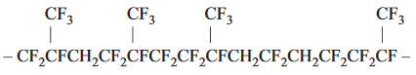

The two monomers are
  - CH₂=CF₂ and CF₂=CFCF₃
  - CF₂=CF₂ and CF₂=CFCF₃
  - CH₂=CF₂ and CH₂=CFCF₃
  - CF₂=CF₂ and CH₂=CFCF₃

- A short section of a polymer is shown below.

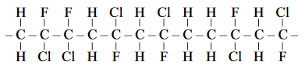

What is the name of the monomer that has been polymerised to make this polymer?
  - 1-chloro-2-fluoroethene
  - 1-chloro-2-fluoropropene
  - 1-chloro-1-fluoroethene
  - 1-fluoro-1-chloroethene

- Consider the addition polymerisation of CH₃CH=CHCH₃.The structure of the resulting polymer would be

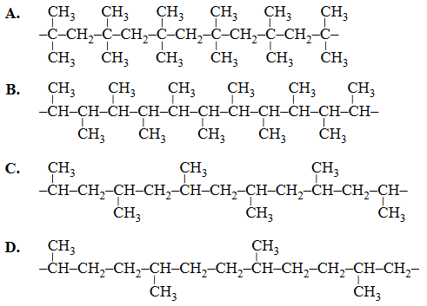
The answer is B.

- The IUPAC name of the polymer formed in question 13 above is
  - Polybutene
  - Polybut-2-ene
  - Poly (butane)
  - Poly (but-2-ene)

PART TWO: SHORT ANSWER QUESTIONS (20 MARKS)
- Draw, using appropriate bracket notation, the polymer that would form from this monomer. Show all atoms and all bonds.
(2 marks)
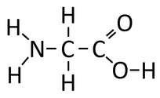

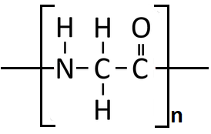
Marking
1 mark for correct use of square brackets, including ‘n’ as a subscript and covalent bonds extending beyond square brackets.
1 mark for all atoms and all bonds
Can be drawn the other way around i.e. -C-C-N-.

- Ethane-1,2-diamine (NH₂CH₂CH₂NH₂) forms a condensation copolymer with butanedioic acid (HOOCCH₂CH₂COOH).
  - Use appropriate square bracket notation to draw the structure of the repeating unit of the copolymer that would be formed. Show all atoms and all bonds.
(3 marks)
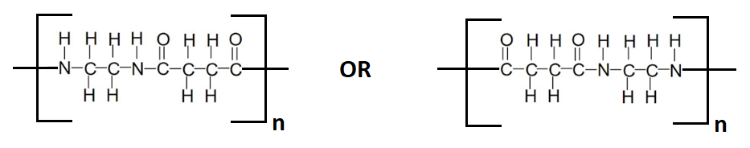
Marking
1 mark for correct use of square brackets, including ‘n’ as a subscript and covalent bonds extending beyond square brackets.
1 mark for amide linkage in the middle
1 mark for all atoms and all bonds

  - Is the polymer formed above a polyester, a polyamide or an addition polymer?
(1 mark)
Polyamide
- Cellulose is the plant polymer referred to as ‘fibre’ when it forms part of the human diet. A short section of cellulose is shown below.

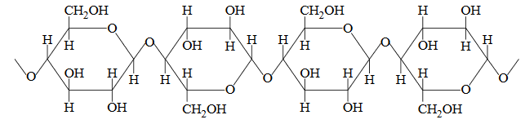

  - When two monomers join during cellulose formation, a molecule of water is lost. Is cellulose an addition polymer, a polyamide, a polyester or none of these? Explain how you know by referring to structure/s shown in the diagram above.
(4 marks)
It is none of these (1).
It is not an addition polymer because there is no backbone of carbon atoms / because water was released (1).
It is not a polyamide because there are no amide linkages (1).
It is not a polyester because there are no ester linkages (1).
Other answers may be acceptable, at the teacher’s discretion.

  - Draw one of the monomers that are polymerised to make cellulose.
(1 mark)
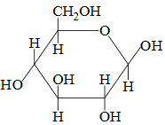

1 mark for structure with no mistakes. No part marks. Bond angles do not need to be exactly the same as above.

OK to draw the monomer upside down.

- Perspex (polymethyl methacrylate) is a clear, colourless polymer used for optical applications. The structural formula of the only monomer used in the synthesis of perspex, methyl methacrylate, is shown below.

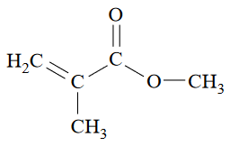

Draw a section of the polymer showing exactly two units of the monomer.
(3 marks)
Any of these representations are acceptable.
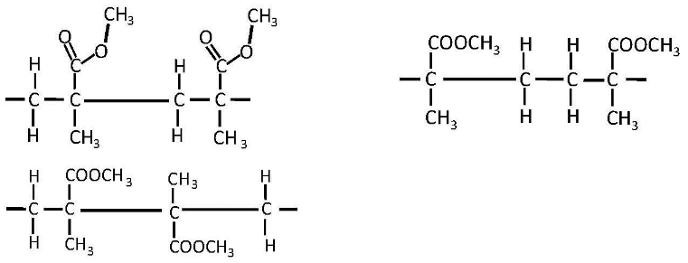
1 mark for 4 carbon atoms in the backbone.
1 mark for all attachments to the carbon backbone.
1 mark for open bonds at both ends.

- Dacron is the trade name for a common polyester used in making clothes and water bottles. Part of its structural formula is given below:

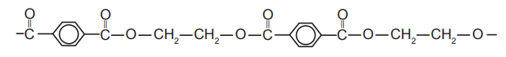

  - Draw the structural formula for the two monomers that react to form this polymer.
(2 marks)
Monomer 1
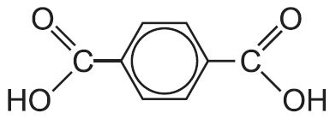
Monomer 2

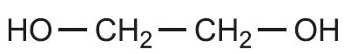

1 mark per structure with no mistakes.

  - Predict and explain the effect on the polyester’s rigidity and melting point as the polymer chains increase in length.
(4 marks)
(Increasing the length of the polymer chain increases the molar mass which)
Increases the dispersion forces (of the benzene rings and alkyl sections of the polymers)
(1)
And increases the number of dipole – dipole attractions along the length of the polymer chains
(1)
This increases the magnitude of its interactions / strength of the intermolecular forces with neighbouring chains making the polymer more rigid
(1)
More energy is required to overcome the attraction of the chains of the polymer from each other / to overcome the intermolecular forces thereby raising the melting point
(1)

